Top of Form

# Setup Guide

This document will (hopefully) help you get your computer ready for assignments.

# Setting up GitLab:

All of your code needed to be uploaded (pushed) to GitLab. Whatever is "pushed" to GitLab before the due date will be considered as your final submission.

1. Log into GitLab [here](https://gitlab.cas.mcmaster.ca/users/sign_in) (https://gitlab.cas.mcmaster.ca/)
2. Press the "New Project" button
3. Press "Create Blank Project"
4. Name your project "MT2MP3"
5. Set your visibility to "Private"
6. Create the project.

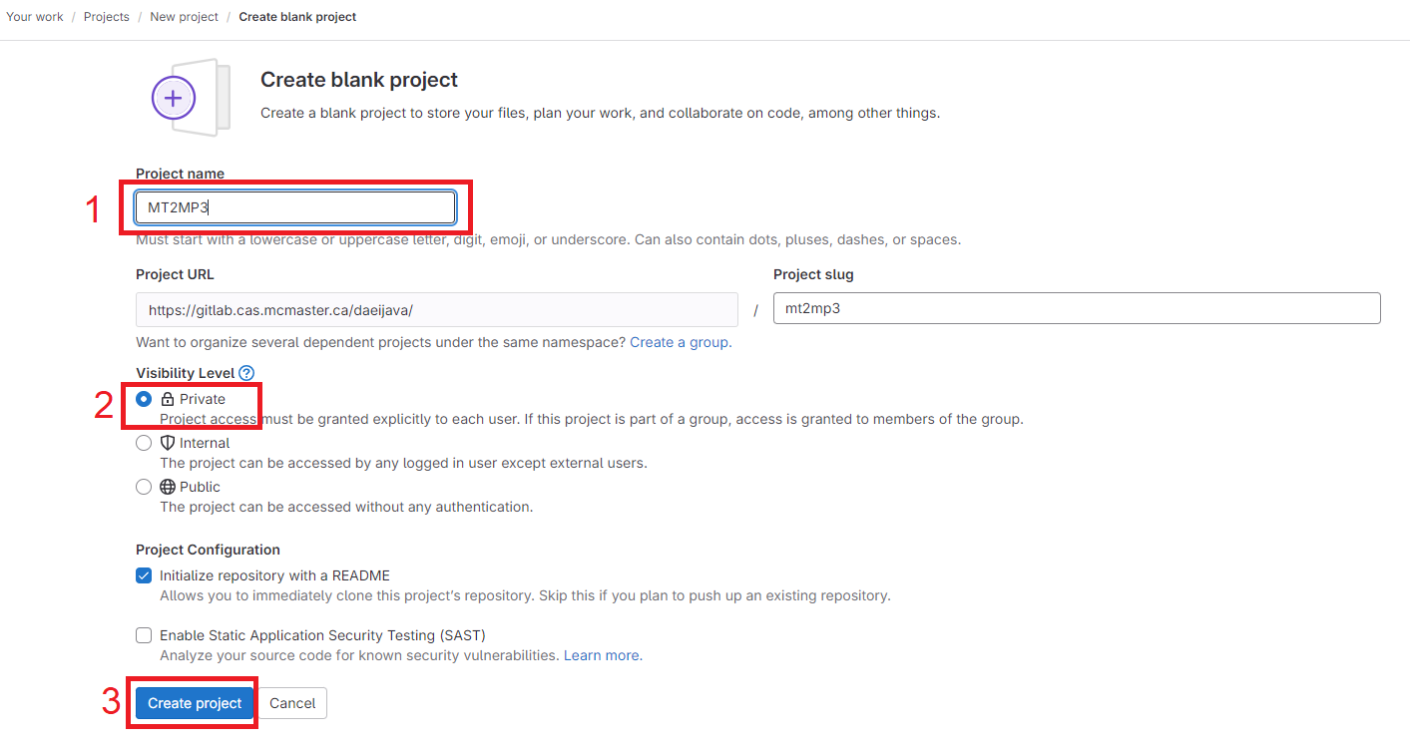

* Each assessment will have a separate directory within this Project (repository). It is highly important that your files and folders follow a strict naming convention. Please use  
  directory names as given. Assignment folders shall be named A1, A2, A3, A4, and A5.
* It is critically important that your submission repository remain private at all times. Failure to keep your submission repository in a private state may result in a charge of academic dishonesty.
* In order for us to collect your submissions, it is necessary that the grad TA is invited as a member to your submission repository. In the following there is the instruction to do so.

1. Open the project MT2MP3. Menu -> Project -> Your projects.
2. Go to the menu on the left, then Manage -> Members.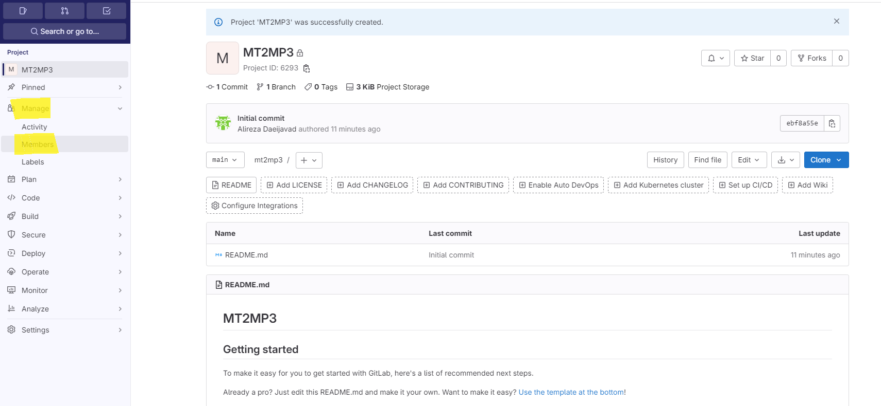
3. Press “Invite members” and the fill the information as here:
   1. Email: [Daeijava@mcmaster.ca](mailto:Daeijava@mcmaster.ca)
   2. Role: Maintainer
   3. 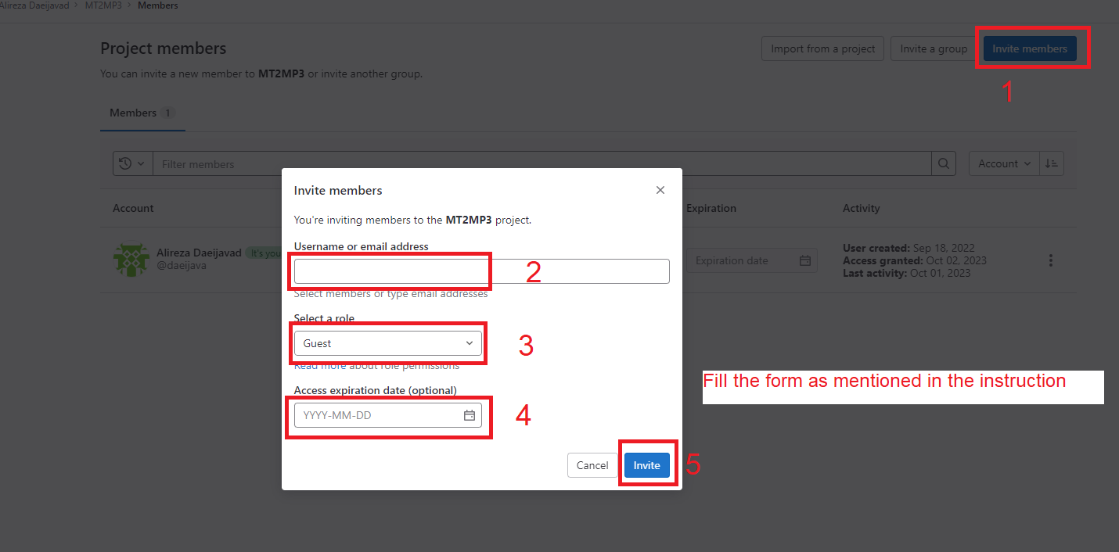Access expiration date: 29/Feb/2024